Memory Card & TRC Interface

This section contains flowcharts for the memory card interface and other TRC requirements for the three platforms.

Goals
- Keep it simple; the game is targeted at a casual audience.
  - Avoid filename or other complex interfaces.
- Auto-load most recently saved game upon boot-up.

Boot Up Process

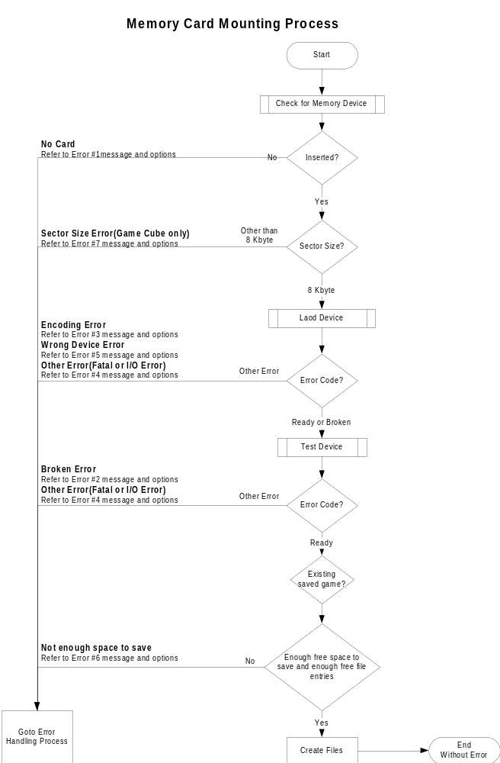

Error Handling Process

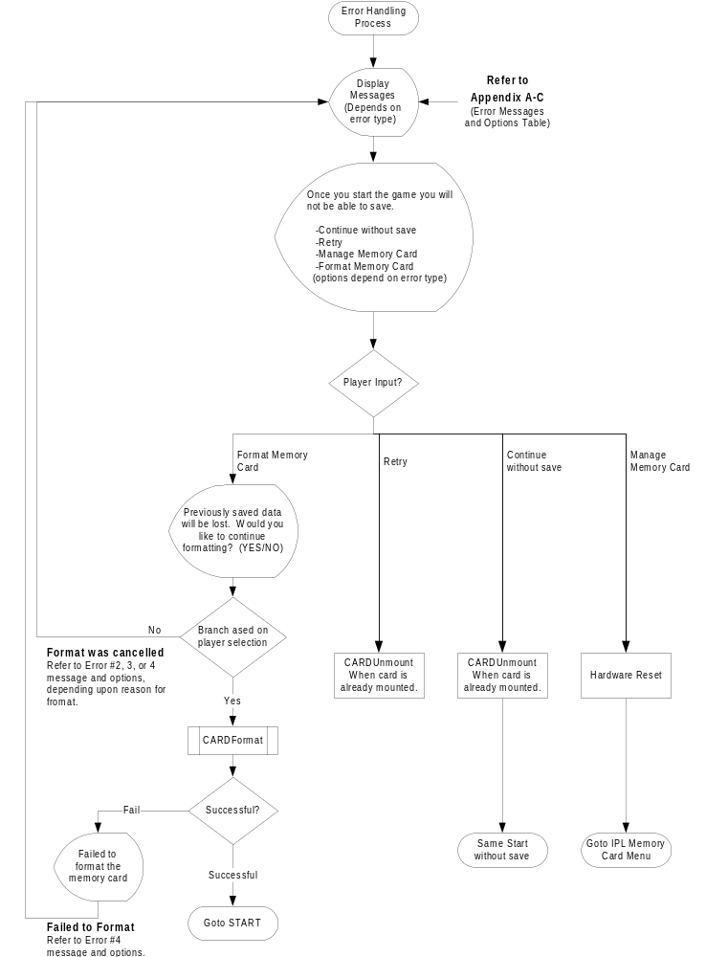

Load Game
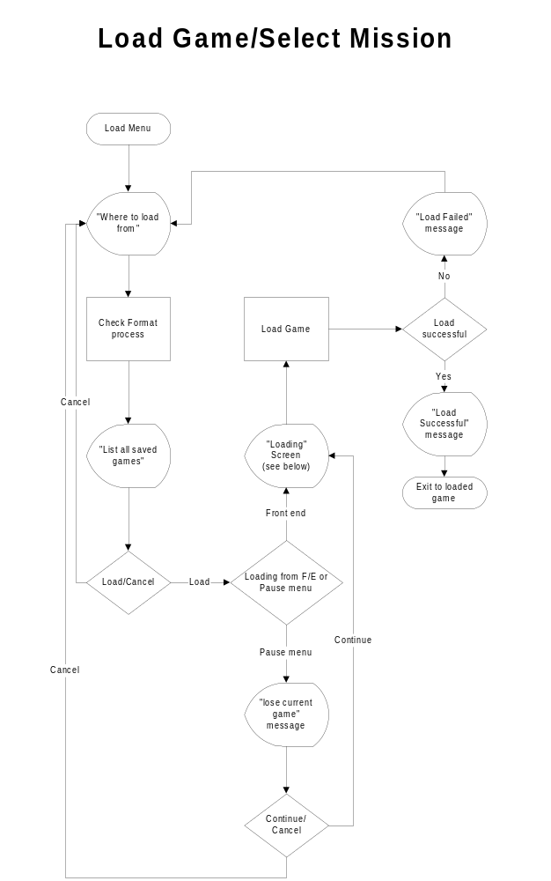

Save Game

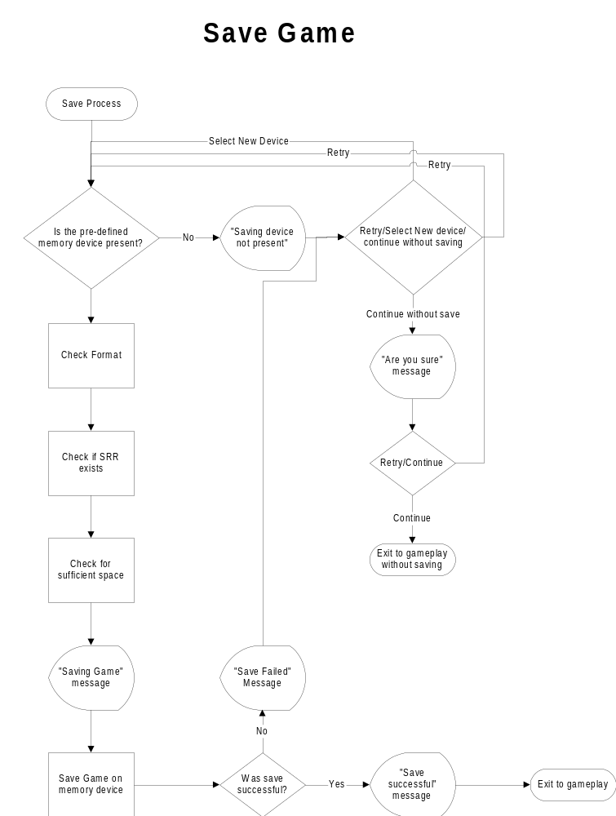

Appendix A (Error Handling messages for Game Cube)

Error Number | Error Type | Message | Selectable player Options
Error Number | Error Type | Message | Continue without save | Retry | Manage Memory Card | Format Memory Card
1 | No Memory Card inserted | No Memory Card found in Slot <A or B> | X | X | --- | ---
2 | System area is corrupted | The Memory Card in Slot <A or B> is corrupted and needs to be formatted. | X | X | --- | X
3 | Formatted for another market | The Memory Card in Slot <A or B> is not formatted for this market. To Save the <Game Title> file, you will need to format the Memory Card. | X | X | --- | X
4 | Failed to format Or Physically damaged | The Memory Card in Slot <A or B> is damaged and cannot be used. | X | X | --- | ---
5 | Device other than Memory Card | Another device in Slot <A or B>. Please insert a Memory Card. | X | X | --- | ---
6 | Not enough space to save | There is not enough space on the Memory Card in Slot <A or B>. In order to save <Game Title>, Y files and X blocks are required. | X | X | X | ---
7 | Other than 8 Kbyte sector size | The Memory Card in Slot <Aor B> is not compatible with the <Game Title> save file. | X | X | --- | ---

Appendix B (Error Handling messages for PlayStation 2)

Error Number | Error Type | Message | Selectable player Options
Error Number | Error Type | Message | Continue without save | Retry | Manage Memory Card | Format Memory Card
1 | No Memory Card inserted | Memory card (8MB) (for PlayStation 2) is not inserted into MEMORY CARD slot 1 | X | X | --- | ---
2 | System area is corrupted |  | X | X | --- | X
3 | Formatted for another market | Memory card (8MB) (for PlayStation 2) is unformatted. Do you want to format? (YES/NO) | X | X | --- | X
4 | Failed to format Or Physically damaged |  | X | X | --- | ---
5 | Device other than Memory Card |  | X | X | --- | ---
6 | Not enough space to save | There is insufficient space. At least xx KB is needed to save this game data. Do you want to start? (YES/NO) | X | X | X | ---

Appendix C (Error Handling messages for Xbox)

Error Number | Error Type | Message | Selectable player Options
Error Number | Error Type | Message | Continue without save | Retry | Manage Memory Card | Format Memory Card
1 | No Memory Card inserted |  | X | X | --- | ---
2 | System area is corrupted |  | X | X | --- | X
3 | Formatted for another market |  | X | X | --- | X
4 | Failed to format Or Physically damaged |  | X | X | --- | ---
5 | Device other than Memory Card |  | X | X | --- | ---
6 | Not enough space to save | Your Xbox doesn’t have enough free blocks to save games. Press A to continue without save of B to free more blocks. | X | X | X | ---

